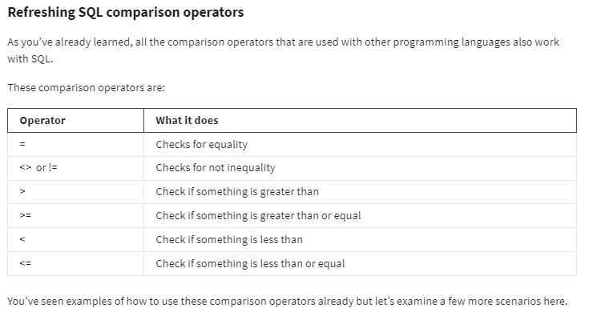

**Using the equality operator**

SELECT * FROM employee WHERE employee_id = 1;

SELECT * FROM employee WHERE employee_name = 'James';

## ****Using the inequality operator****

SELECT *

FROM employee

WHERE salary <> 24000;

## ****Using the greater than operator****

SELECT *

FROM employee

WHERE salary > 50000;

## ****Using the greater than or equal operator****

SELECT *

FROM employee

WHERE tax >= 1000;

## ****Using the less than operator****

SELECT *

FROM employee

WHERE allowance < 2500;

## ****Using the less than or equal operator****

SELECT *

FROM employee

WHERE hours <= 10;